MAKE SKILLED IoT INTERNSHIP

ASSIGNMENT – 14

ARDUINO LOGICAL THINKING TASK

**Count the number of persons entering into a room / hall.**

* HERE WE WILL BE USING ARDUINO INTERFACE.
  + COMPONENTS REQUIRED:
  1. ARDUINO UNO BOARD
  2. PC / LAPTOP INSTALLED WITH ARDUINO IDE SOFTWARE
  3. Ultrasonic SENSOR
  4. BUZZER
  5. JUMPING WIRES
* CIRCUIT DIAGRAM 1
* 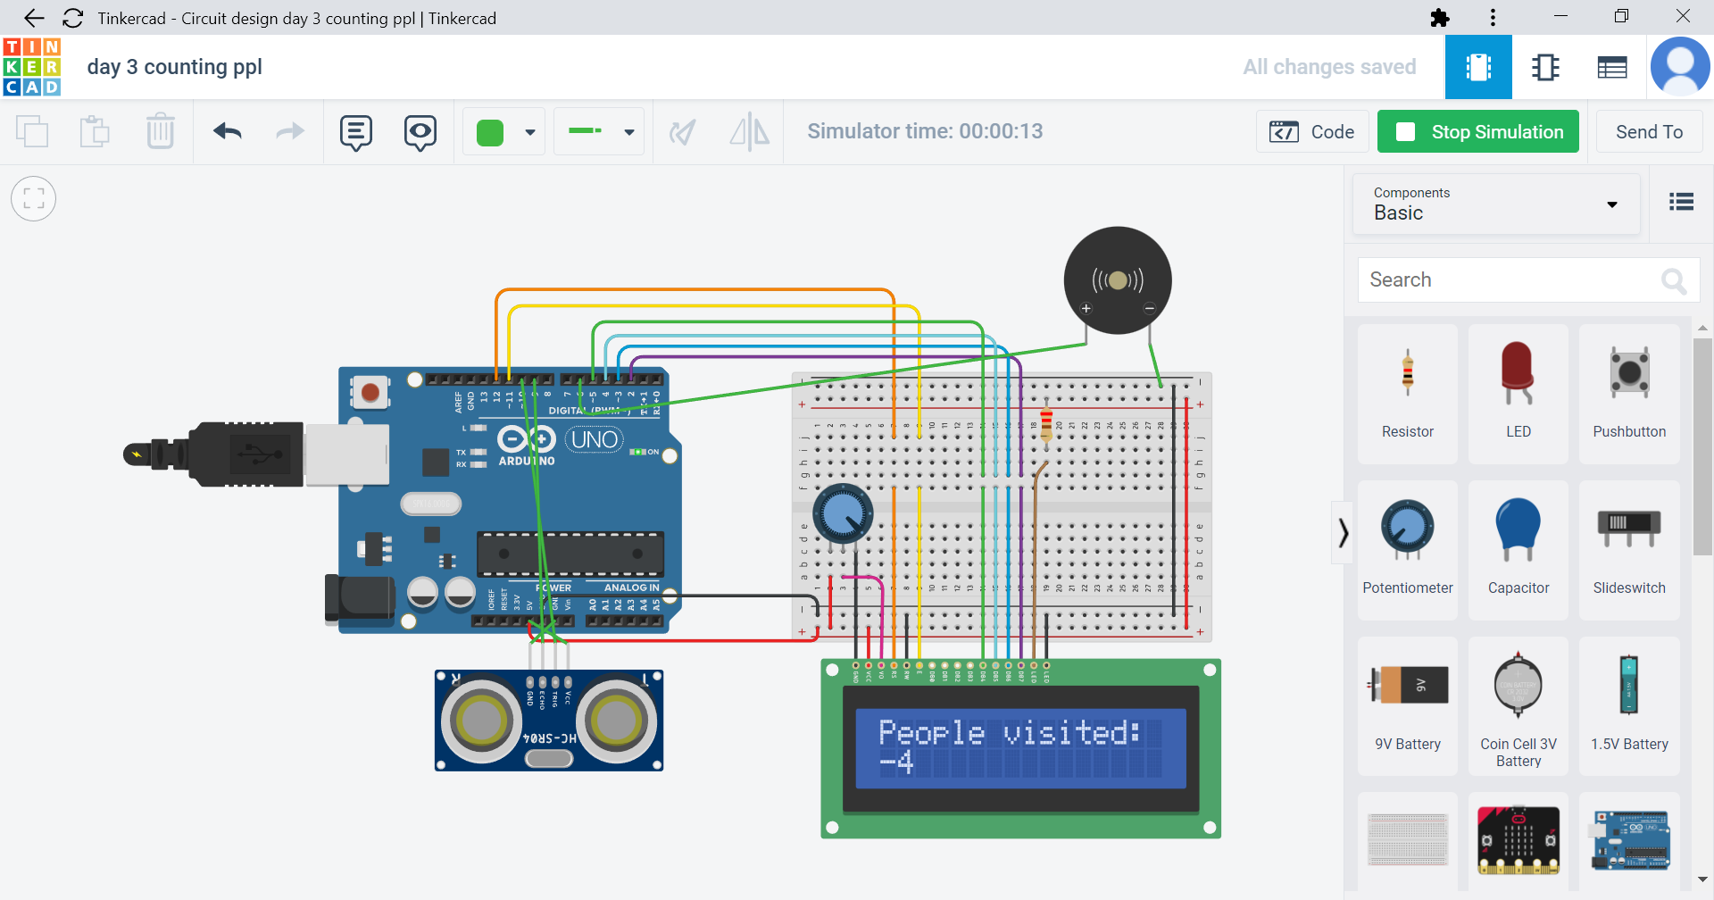

* PROGRAM 1

int trig = 10;

int fan =8;

int echo = 9;

int led = 7;

int buzzer= 6;

int i=0;

#include <LiquidCrystal.h>

LiquidCrystal lcd(12, 11, 5, 4, 3, 2);

void setup()

{

lcd.begin(16, 2);

Serial.begin(9600);

pinMode(trig,OUTPUT);

pinMode(echo,INPUT);

pinMode(led,7);

pinMode(fan,8);

pinMode(buzzer,OUTPUT);

}

void loop() {

lcd.setCursor(0,0);

lcd.print("People visited:");

digitalWrite(trig,LOW);

delayMicroseconds(5);

digitalWrite(trig,HIGH);

delayMicroseconds(10);

digitalWrite(trig,LOW);

int a = pulseIn(echo,HIGH);

int distance = a*0.034/2;

if ( distance<40) //in

{

i=i+1;

delay(500);

digitalWrite(buzzer,HIGH);

delay(100);

digitalWrite(buzzer,LOW);

delay(100);

lcd.clear();

lcd.setCursor(0,0);

lcd.print("People visited:");

lcd.setCursor(0,1);

lcd.print(i);

delay(400);

}

if ( distance>60) //out

{

i=i-1;

delay(500);

digitalWrite(buzzer,HIGH);

delay(100);

digitalWrite(buzzer,LOW);

delay(100);

lcd.clear();

lcd.setCursor(0,0);

lcd.print("People visited:");

lcd.setCursor(0,1);

lcd.print(i);

delay(400);

}

}

**By Team : AKULA ZAHEER SHA , TAUFEEQ BASHA & QUIZER SHAH**